20.57: The much larger mass of water suggests that the final state of the system will be water at a temperature between 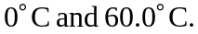This temperature would be

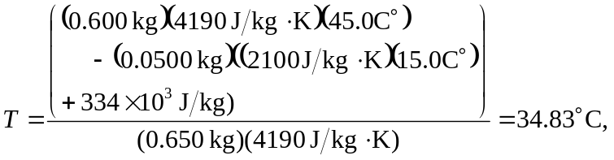

keeping an extra figure. The entropy change of the system is then
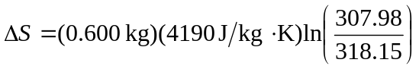
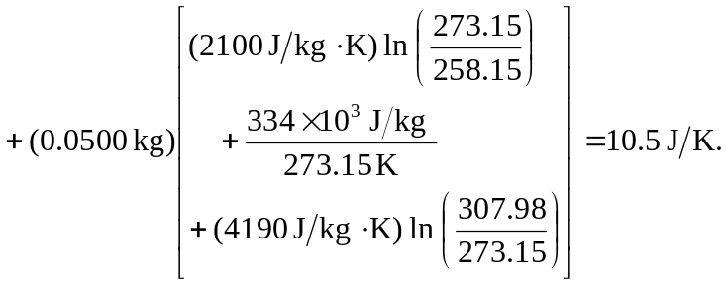
(Some precision is lost in taking the logarithms of numbers close to unity.)

